# Crop Deals App - Low-Level Design (LLD)

**Objective:**

CropDeal is a microservices-based system designed for farmers, dealers, and admins to interact around crop listing, purchasing, and payment. It utilizes Spring Boot, Spring Eureka, and a Gateway for service communication.

**Architecture Overview:**

The Crop Deals App follows a microservices-based architecture using Spring Boot. It comprises several microservices, an API Gateway, and a Eureka Server for service registration and discovery.

**Microservices Involved**

1. **API Gateway**
2. **Discovery Server (Eureka)**
3. **Admin Service**
4. **Farmer Service**
5. **Dealer Service**
6. **Crop Details Service**
7. **Payment Service**
8. **Auth Service**

**1. API Gateway**

- Technology: Spring Cloud Gateway

## - Responsibilities

- Routing client requests to appropriate services

- Handling JWT-based authentication

- Managing cross-cutting concerns (e.g., security, logging)

- Fallback mechanisms for fault tolerance

**2. Eureka Server**

- Technology: Netflix Eureka

## - Responsibilities

- Service registration and discovery

- Monitoring service health

**3. Admin Microservice**

- Technology: Spring Boot

## - Routes

- `/admin/farmers` - Number of registered farmers

- `/admin/dealers` - Number of registered dealers

## - Responsibilities

- Authentication, Authorization

- Aggregating and reporting data

**4. Farmer Microservice**

- Technology: Spring Boot

## - Routes

- `/farmer` (POST) - Add farmer

- `/farmer/{id}` (GET/PUT/DELETE) - CRUD by ID

## - Responsibilities

- Managing farmer profiles and operations

**5. Crops Microservice**

- Technology: Spring Boot

## - Routes

- `/crops/all` - All crops

- `/farmer/{id}/all` - Farmer's crops

- `/crops/crop/{name}/all` - Crop by name

- `/crops/active/all`, `/crops/inactive/{id}` - Active/inactive crops

## - Responsibilities

- Crop management, status updates

**6. Dealer Microservice**

- Technology: Spring Boot

## - Routes

- `/dealer/all` - All dealers

## - Responsibilities

- Dealer profile and CRUD operations

**7. Payment Microservice**

- Technology: Spring Boot

## - Routes

- `/payment` - Process payment

- `/payment/{id}` - Payment details by ID

## - Responsibilities

- Payment processing and records

## Flow Diagram

The following diagram illustrates the architecture and USE-CASE Diagram between different services in the CropDeal system.

USE-CASE DIAGRAM

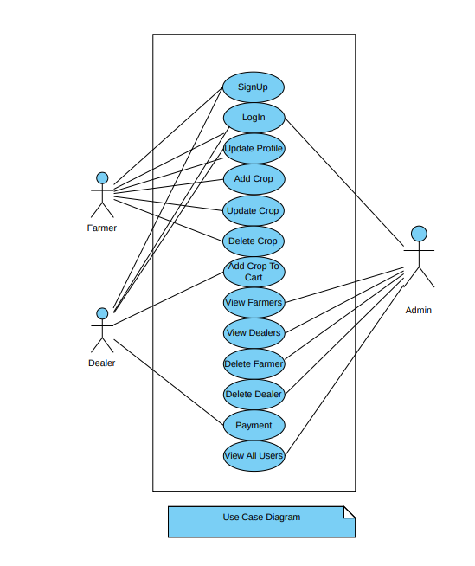

Class Diagram

ER- Diagram

ARCHITECTURE-DIAGRAM

